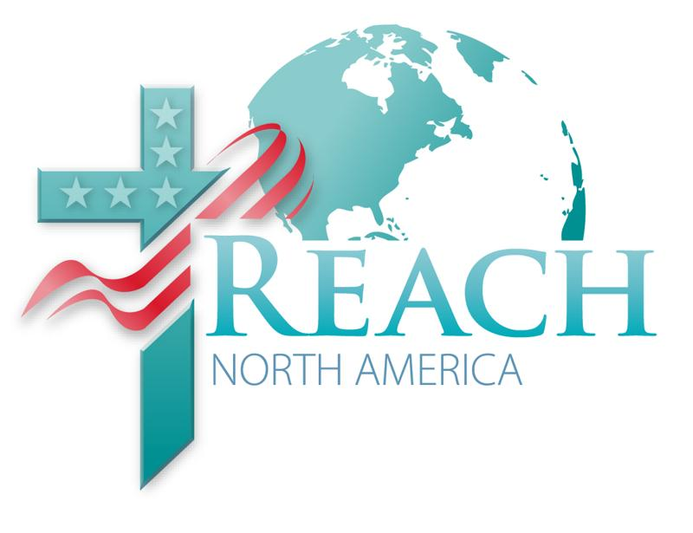
Volume 3, December 22, 2010
Share and Care
This is the last newsletter you’ll receive before the special broadcasts of prayer and reformation beginning December 25 and on into the first of January. All the information you need to participate is accessible through this newsletter devoted to holiday programming and resources. Plan to share the special programming offered by both the General Conference and the North American Division with your congregation.

With every New Year comes another opportunity to renew and reposition our lives. Most of us feel the need to set goals, redirect our course in order to be productive and representative of a healthy, well-rounded Christian. Several broadcasts have been planned to assist with that process.

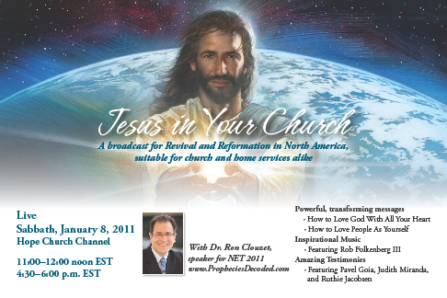
Day of Prayer and Reformation
January 8, 2011, 11:00-12:00 pm ET, 4:30-6:00 pm ET

The one hour broadcast will be uplinked so that all churches in North America can downlink live or record for a worship service and an afternoon program. The programs are planned to bring revival and preparation for a new year of evangelism and outreach activities. Local churches may enhance the broadcasts with activities that expressly describe the goals for their congregation.

Worship
Welcome and prayer
Ministry of music
Sermon: How to Love God with All Your Heart, Ron E. M. Clouzet
Appeal song
Closing prayer

Afternoon Session
Welcome and prayer
Ministry of music
Interviews: Judith Miranda, Pavel Goia, Ruthie Jacobsen
Ministry of music
Sermon: How to Love Your Neighbor as Yourself, Ron E. M. Clouzet

Hope Church Channel Uplinks
December 25-January 2, 2011 . . . Revival and Reformation programming. The following are some
highlights you won’t want to miss,.
December 25 . . . . Following the Path Jesus Took for Our Salvation, Christmas Day sermon, GC President Ted N. C. Wilson.
December 31 . . . . Revival and Reformation: A World Day of Prayer
January 1. . . New Year’s Day sermon, GC President
January 8. . . Day of Prayer and Reformation, worship service
Day of Prayer and Reformation, afternoon session
(CTZ, MTZ, PTZ should record and use as convenient)
Revival and Reformation programs produced by General Conference’s initiative of the same name also includes a program emphasizing prayer and featuring interviews with each of the world church’s division presidents and a series of daily inspirational messages from some of the church’s best-known speakers—Derek Morris, C.D. Brooks, Doug Batchelor, Dwight Nelson, José Rojas, and Mark Finley.

For full schedule, times and dates, visit www.HopeTV.org. The network encourages viewers to record the programs to play later for church services, Sabbath Schools, prayer meetings, vespers services, or other gatherings.

Hope Channel Uplinks
December 25-January 1, 2011 . . . Revival and Reformation programming. See HCC notes above.

During the month of December, Hope TV is offering a number of holiday programs for both home and church. Check out Hope Channel and Hope Church Channel at www.hopetv.org
g
Need something special for Christmas and New Years? Visit www.adventistpreaching.com or AdventSource 800-328-0525, for sermon series by your favorite preachers. Volume 24 of great Adventist Preaching, A Collection of Holiday Sermons, is the perfect choice to enhance your holiday services. Sermons come with music. 3-DVD set of 9 sermons/services is $29.95 + sh/h.

REACH North America
A publication of the North American Division for Evangelism and Outreach

