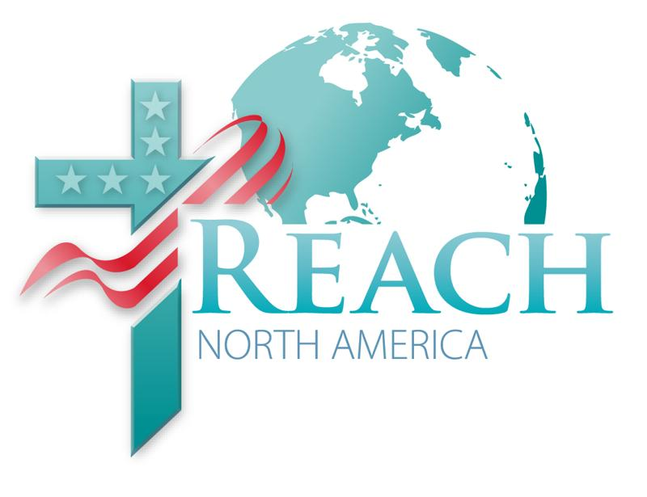
Volume 4, January 5, 2011
Share and Care

Day of Prayer and Restoration is this coming weekend. Two programs have been planned and will be uplinked for use on Sabbath, January 8. There is a worship service with music by Rob Folkenberg, III, and sermon by Ron Clouzet. The afternoon meeting will include the above, except Clouzet will preach a second sermon plus you’ll hear inspiring interviews and prayer initiatives. Attend with an open heart, ready to be energized and motivated for another year.

There are some important tips in this newsletter. Don’t miss them. It will make the online registration process easier. And, Dr. Clouzet has set up a NET 2011 prayer blog site! Check it out.

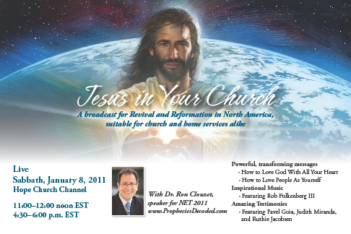

Jesus in Your Church
Sabbath, January 8

The first nationwide NET 2011 related event will be this Sabbath, January 8, 11:00-12:00 noon and 4:30-6:00 pm EST on Hope Church Channel.

The live event, Jesus in Your Church, will feature NET 11 speaker Ron Clouzet, Director of NADEI, with two biblical, inspirational, and practical messages. Fred Kinsey, Director/Speaker of the Voice of Prophecy, will be the telecast’s MC. It will also introduce a new musical talent, Rob Folkenberg III, and provide lively interviews with Judith Miranda, soul winner extraordinaire, and Pastor Pavel Goia, subject of Greg Budd’s recently published book by the Review & Herald Publishing Association, One Miracle After Another: The Pavel Goia Story. Ruthie Jacobsen, NAD Prayer Ministries Coordinator, will launch a major prayer initiative across the Division.

Please join us for this revival opportunity as we look for the Holy Spirit to make a never-before-seen impact in the North American Division, urges Clouzet.

Please share this information with your church family, sister churches and anyone who is seeking a renewed experience with the Lord in the coming year.

NET 2011 website: http://host.propheciesdecoded.com
Ron Clouzet’s NET prayer blog: www.Pray4NET.blogspot.com

NET 2011 Prayer Blog

Ron Clouzet has just posted his first blog! He says, “I”ve never done this before but hope to learn along the way. I plan to use it to post news and items to pray for regarding NET 2011.”

You can read the blog at http://www.pray4net.blogspot.com/

Trouble registering online for Prophecies Decoded?
Try once more and follow these tips.

For pastors using the new Google Chrome browser, there is an autocomplete form that is causing a problem. The form thinks the autocomplete is spam, so it won't allow them to register. The form is working in all the other browsers such as Explorer, Firefox and Safari without problems.

Solution: Notice the note at the top of the form to either turn off Autocomplete if the user is using Google Chrome, or use another browser.

If you continue to have problems, please let us know.

Registration: As of today, there are 50 sites registered! Praise God! Planning ahead is always a good idea.

Creation Seminar with Dr. Timothy Standish and Dr. Ron E. M. Clouzet
The Greatest Show on Earth: Making Sense of the Creation-Evolution Debate

NEW DATES! May 4-8, 2011 (changed from May 11-15)
Please make note of this change in your pastor’s packet.

A scientist and a practical theologian present evidence you’ll not want to miss in the next preparatory event of NET 2011—Prophecies Decoded.

Choose to use this quality seminar to invite community friends and neighbors and all those interested in this hot topic of our times to your church. 5 nights and 5 important topics to be broadcast live on the Hope Channel. Plan to participate.

Prophecies Decoded: Can the Past Reveal Your Future
September 30—October 29, 2011
Speaker—Ron Clouzet, Director, North American Division Evangelism Institute

Resource Sites:
http://host.PropheciesDecoded.com for more program information, organization tips,
resources and registration for NET 2011—Prophecies Decoded.
855-NET-2011 for registration and technical assistance.
www.AdventistSat.com to order equipment online.
www.AdventistEvangelism.com to order printed materials.

REACH North America
A publication of the North American Division for Evangelism and Outreach

