  1 | Copyright Info
2 | OXYGEN Info
3 | Manuscript © 2003 David Newman
4 | Blank Screen
5 | “Why Do I Need Other People In My Life?”
6 | We live in a world where there are so many calls for our attention that we often feel out of control. See if you identify with what one person wrote as the Ten Signs Your Life Is Getting out of Control:
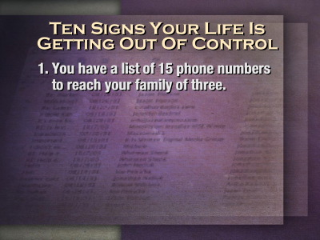7 | - You have a list of 15 phone numbers to reach your family of three.
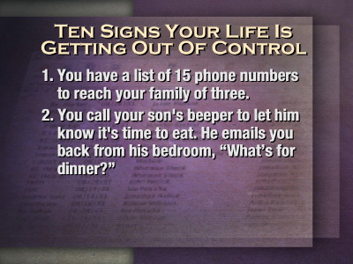8 | - You call your son's beeper to let him know it's time to eat. He e-mails you back from his bedroom, "What's for dinner?"
9 | - Your daughter sells Girl Scout Cookies via her Web site.
10 | - You chat several times a day with a stranger from South Africa, but you haven't spoken with your next-door neighbor yet this year.
11 | - Your grandmother clogs up your e-mail inbox asking you to send her a JPEG file of your newborn so she can create a screen saver.
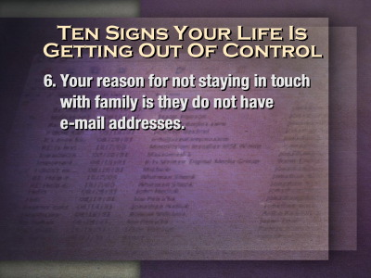12 | - Your reason for not staying in touch with family is they do not have e-mail addresses.
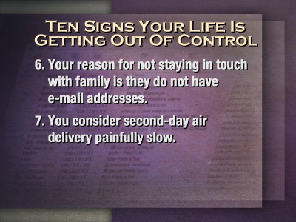13 | - You consider second-day air delivery painfully slow.
14 | - You hear most of your jokes via e-mail instead of in person.
15 | - You're reading this.
16 | - Even worse, you're going to forward it to someone else.  Talk about forwarding stuff? I have many good meaning people who forward all kinds of stuff to me. I have no doubt that much of it is excellent but I receive so much there is not enough time in the day to look at it all. So how do we get our life under control? How do we get out of the rat race?  How do we cope with the multitude of pressures that our technological age has brought? How do we cope with the cell phone that is attached to many of us closer than our arm? How do we keep our sanity? We learn balance by letting others hold us accountable. And this is best done in small groups.
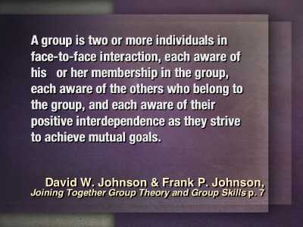17 | “A group is two or more individuals in face-to-face interaction, each aware of his or her membership in the group, each aware of the others who belong to the group, and each aware of their positive interdependence as they strive to achieve mutual goals.”  David W. Johnson & Frank P. Johnson, Joining Together Group Theory and Group Skills  ( Englewood Cliffs: Prentice-Hall, 1982), p. 7.
18 | The composition teacher asked the class to write about an unusual event that happened during the past week. Little Johnny got up and read his essay.  It began, "Daddy fell into the well last week..."  "Oh, my!" the teacher exclaimed. "Is he all right?"  "He must be," said the boy. "He stopped yelling for help yesterday."  Johnny and his family even though they were a small group, were not very response to Dad’s cries for help.
19 | We are surrounded in the church, in the workplace, in our community with people in need crying out for help. Sometimes the cries stop and we assume they're now all right. The truth may well be that they have grown weary of seeing their appeals unanswered. There may be people even of this church who are listed as members of this church but who no longer attend. Their cries for help have gone unheeded and we no longer hear them at all!  We need each other in ways that we never dreamed of and this help is best provided in community, in small groups. God made us to exist within small groups. How do I know?
20 | When God created the world He said at the end of each day that “Everything was good.”
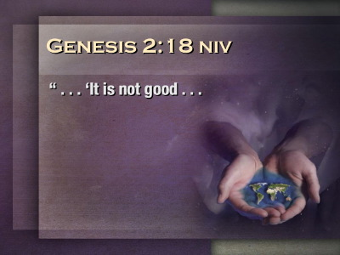21 | But in Genesis 2:18 God said “… It is not good . . .”
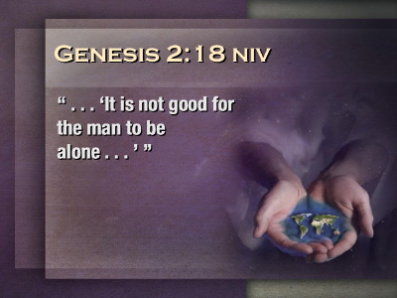22 | Can you complete the rest of the sentence? “… for the man to be alone…”
23 | Wasn’t God enough for Adam? No he was not. When we comfort someone and say “God is all you need. Go to Jesus and He will help you through every trial.” We are telling them to do something that God did not intend for us to do.  When God created humans He created us to sleep. We need God and sleep. God created us to eat. He could have made us spirit beings with no need to eat physical food but He did not. We need God and food. God could have made us to be solitary creatures, to exist without the need of human friends relying on God alone. But God did not.  He said “It is not good for humans to be alone.” He made us to be like Him, to live in community, in small groups.
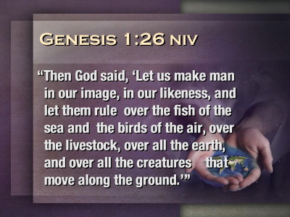24 | “Then God said, ‘Let us make man in our image, in our likeness, and let them rule over the fish of the sea and the birds of the air, over the livestock, over all the earth, and over all the creatures that move along the ground.’”  (Genesis 1:26).  When God made the first humans He said “let us make man, humans, in our image.” Here we have the clear indication of a plurality within the Godhead. I believe it is also significant that the word used for God in the early chapters of Genesis is Elohim which is the plural form of god.  God intended for us to live in groups not by ourselves and He modeled that right from the beginning.
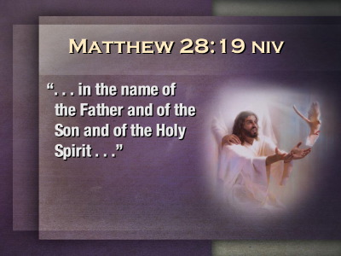25 | God lives within the context of a small group.  The Bible tells us that the Godhead is made up of three persons, The Father, The Son, and Holy Spirit.  (Matthew 28:19-20).
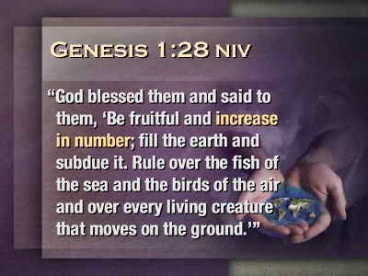26 | “God blessed them and said to them, ‘Be fruitful and increase in number; fill the earth and subdue it. Rule over the fish of the sea and the birds of the air and over every living creature that moves on the ground.’”  (Genesis 1:28)  “Increase in number.” When Adam and Eve had their first child how many did that make in their group? Three. Three, just the same as the number in the Godhead. Why did God create us needing each other? I don’t know all the answers except He intended us to encourage each other and support each other.
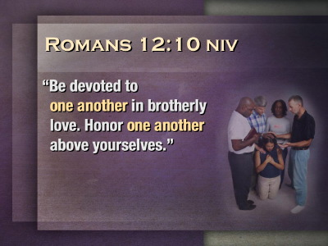27 | Notice some of these “one another” passages in the Bible.  “Be devoted to one another in brotherly love. Honor one another above yourselves.”  (Romans 12:10)
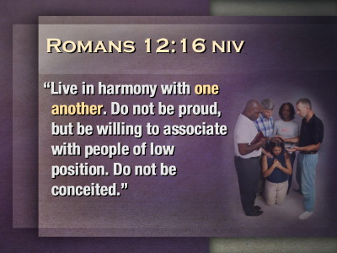28 | “Live in harmony with one another. Do not be proud, but be willing to associate with people of low position. Do not be conceited.”  ( Romans 12:16)
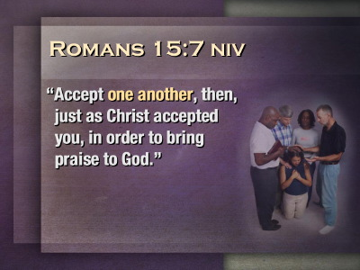29 | Accept one another, then, just as Christ accepted you, in order to bring praise to God.  ( Romans 15:7)
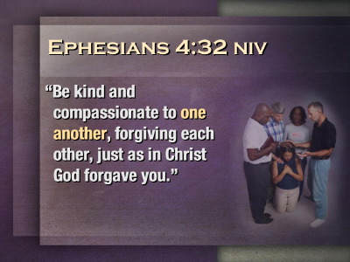30 | “ Be kind and compassionate to one another, forgiving each other, just as in Christ God forgave you.”  (Ephesians 4:32)
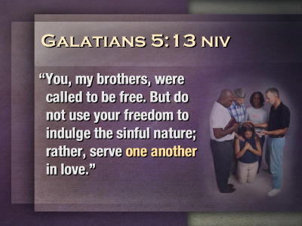31 | ”You, my brothers, were called to be free. But do not use your freedom to indulge the sinful nature; rather, serve one another in love.”  ( Galatians 5:13)
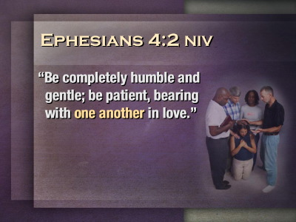32 | “Be completely humble and gentle; be patient, bearing with one another in love.”  (Ephesians 4:2)
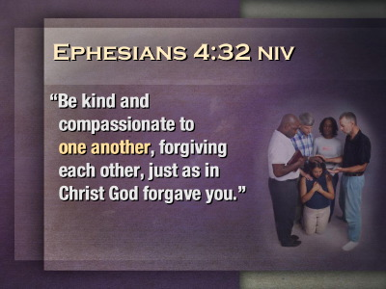33 | “Be kind and compassionate to one another, forgiving each other, just as in Christ God forgave you.”  (Ephesians 4:32)
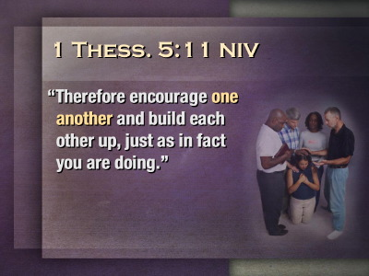34 | “Therefore encourage one another and build each other up, just as in fact you are doing.”  (1 Thessalonians 5:11)
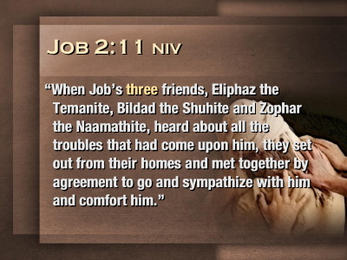35 | Job was in a pickle. He had lost his possessions, his children, and his health. It seemed that he was all alone until three friends turned up.  “When Job's three friends, Eliphaz the Temanite, Bildad the Shuhite and Zophar the Naamathite, heard about all the troubles that had come upon him, they set out from their homes and met together by agreement to go and sympathize with him and comfort him.”  (Job 2:11)
36 | Three friends, a small group, came to comfort Job. When they found him in great distress they sat on the ground with him for a whole week without saying one word. That is friendship. That is support. That is being there for your friend. Unfortunately their silence was much more encouraging than their words. When they opened their mouths they blamed Job for his troubles and told him to confess his sins to God.
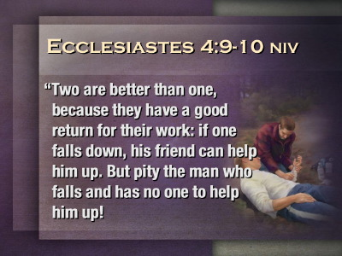37 | But at least Job’s friends started out in the right way. The wise man Solomon gives us this great counsel,  “Two are better than one, because they have a good return for their work: if one falls down, his friend can help him up. But pity the man who falls and has no one to help him up!
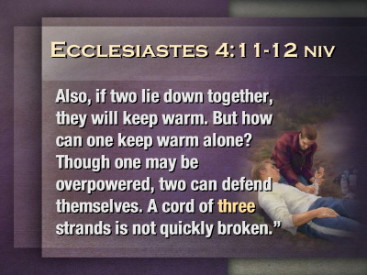38 | Also, if two lie down together, they will keep warm. But how can one keep warm alone? Though one may be overpowered, two can defend themselves. A cord of three strands is not quickly broken.”  (Ecclesiastes 4:9-12)
39 | I have here a piece of string. I will call someone from the congregation to hold one end of the string. We pull and it breaks. I then link three strands of string together. Again we pull. We are unable to break it. This is why the Bible says small groups are so important. This is why we need to be part of a small group. Are you part of a group that meets on a regular basis to study they bible, pray, and encourage one another? If not then you are likely to break.  God said, “It is not good for humans to be alone.” We need each other.  But a small group is not just made up of three or more people. If it is ultimately going to be strong it needs God as an integral part of the group.
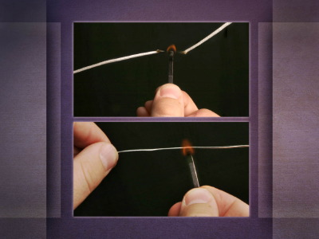40 | Look what happens when I light a match to this string. It breaks again. However, if I take a piece of string, one made of wire, and light the match it does not break. With God as the center of the group we become invincible to the strategies of Satan.  Here is a story of how important other people are in our lives. After an accident in which she lost her arm, a girl named Jamie refused to go to school or church for an entire year. Finally the young teen thought she could face her peers. In preparation, her mother called her Sunday school teacher and asked that he not call attention to Jamie.  The teacher promised, but when he got sick on Sunday and had to call a substitute, he forgot to tell the second teacher. At the conclusion of the lesson that day, which was about inviting friends to church, the sub led the class in doing the hand motions to the familiar children's poem:
41 | Here's the church,  Here's the steeple,  Open the door,  See all the people!  Jamie's eyes filled with tears. A 13-year-old boy realized how she must be feeling. He knelt beside her. With one hand apiece, they supported each other, making the church, steeple, and people. Together they illustrated what the real church is—a community of people encouraging each other.
42 | God said “I did not make you to live alone. I made you to live in community in small groups just as I have lived from all eternity in a small group.” Whose hand are we holding? Whose hand are we making up for? Who are we encouraging?  Jesus, who was also God, modeled the importance of small groups when He lived on this earth. He surrounded himself with twelve disciples and then chose an inner core of three disciple—Peter, James, and John.  The night before He died He took his disciples with Him to the Garden of Gethsemane. He asked them to pray with him, to encourage him. He took Peter, James, and John, a little further into the garden and said
43 | “Please watch with me, pray for me, encourage me. What I am going to go through is almost more than I can bear. I need your help.” "My soul is overwhelmed with sorrow to the point of death. Stay here and keep watch with me."  (Matthew 26:38)
44 | We know what took place. They drifted off to sleep and when Jesus came back for the encouragement of His friends they were asleep. At that moment if I had been Jesus I would have gone right back to heaven. Why should I die for people who could not even pray with me? But Jesus loved us too much to let our behavior influence His behavior.  Even though He knew His father, God, He still craved the companionship of others. God made us for relationships. Jesus, as a man, needed the encouragement of other human beings. He wanted his small group to pray with Him in His terrible agony. The thought of them a few yards behind Him lifting their voices to God would keep Him going through the longest night of His life.  But it was not to be. When Jesus came back to his small group, instead of praying, He found them sleeping. He woke them up and said, “Fellows, I really need your prayers tonight. I am in a crisis. The fate of the world hangs on my decision to night. Please pray for me.”  They nod their heads in agreement and off Jesus goes to agonize in prayer. He feels the need of some more encouragement. He gets up. Returns to His disciples. And wonder of wonders they are back fast asleep again. He wakes them up.  Now if I had been Jesus I would have let them know what a lousy small group they were. Here I was suffering, they could see the beads of sweat pouring off my face. They could see my face distorted by the mental anguish I am going through but they did not seem to care. I would have said, “Look fellows, I am going to find another group of men, a group who really care.”
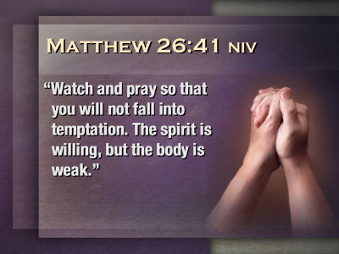45 | Instead, Jesus said, “Watch and pray so that you will not fall into temptation. The spirit is willing, but the body is weak."  (Matthew 26:41)  How gentle Jesus was, how kind, how loving. What an example to us.
46 | When the mob arrived to arrest Jesus everyone of His disciples, His friends, deserted Him. He was left to suffer alone. Jesus knows what it is like to be lonely, to have no one to lean on.  And on the cross when He needed someone with Him the most even His Heavenly Father deserted Him. In awful agony and feelings of abandonment He cried out,
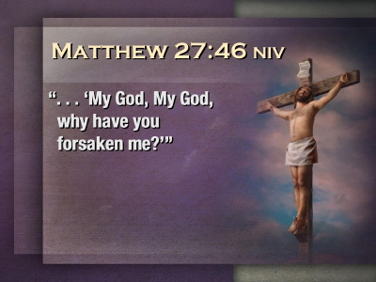47 | “My God, My God, why have you forsaken me?”  (Matthew 27:46)  And then He died—alone—utterly alone. Jesus knows how you feel and is always there for you. He wants you to accept His gracious gift of salvation simply by trusting in His death. Then He says “Go and be a friend to someone for it is not good for people to be alone. Become part of my group. There is a bunch of us who hang out together to encourage each other.”
48 | I don’t want to be one strand of a string. I know that I will break. I want several strands so that together we can grow stronger in our faith in Jesus and like these strands of wire, when the fires of difficulty come,
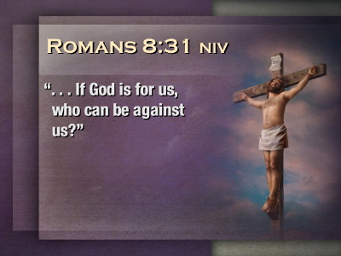49 | nothing can destroy our faith because we know that “if God is for us, who can be against us?”  (Romans 8:31)  and we are part of each other.
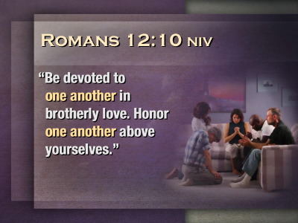50 | One Another Encouragements  Romans 12:10 – “Be devoted to one another in brotherly love. Honor one another above yourselves.”
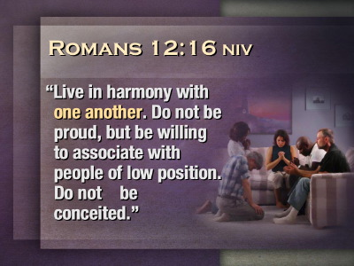51 | Romans 12:16 – Live in harmony with one another. Do not be proud, but be willing to associate with people of low position. Do not be conceited.
52 | Romans 13:8 – Let no debt remain outstanding, except the continuing debt to love one another, for he who loves his fellowman has fulfilled the law.
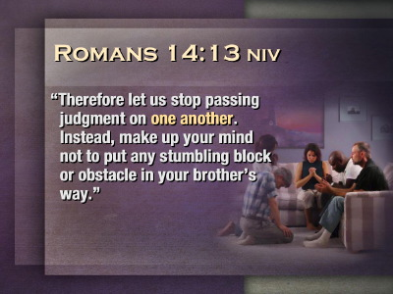53 | Romans 14:13 – Therefore let us stop passing judgment on one another. Instead, make up your mind not to put any stumbling block or obstacle in your brother's way.
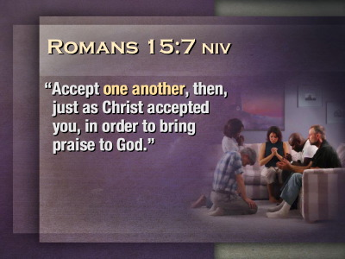54 | Romans 15:7 – Accept one another, then, just as Christ accepted you, in order to bring praise to God.
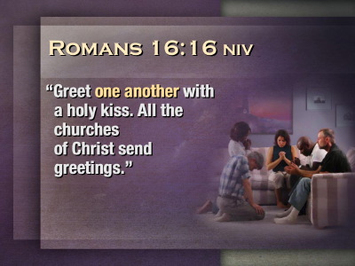55 | Romans 16:16 – Greet one another with a holy kiss. All the churches of Christ send greetings.
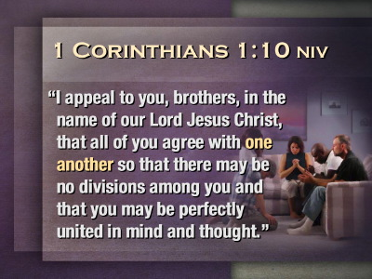56 | 1 Corinthians 1:10 – I appeal to you, brothers, in the name of our Lord Jesus Christ, that all of you agree with one another so that there may be no divisions among you and that you may be perfectly united in mind and thought.
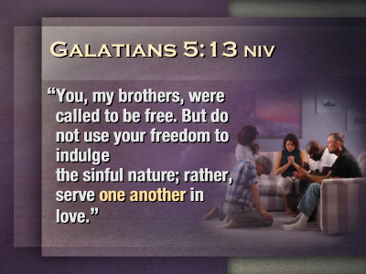57 | Galatians 5:13 – You, my brothers, were called to be free. But do not use your freedom to indulge the sinful nature; rather, serve one another in love.
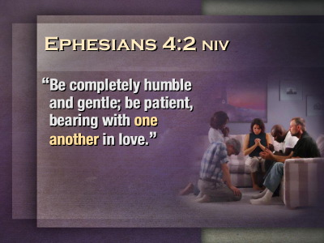58 | Ephesians 4:2 – Be completely humble and gentle; be patient, bearing with one another in love.
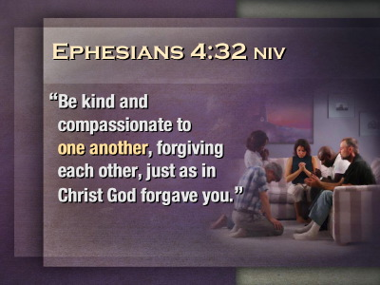59 | Ephesians 4:32 – Be kind and compassionate to one another, forgiving each other, just as in Christ God forgave you.
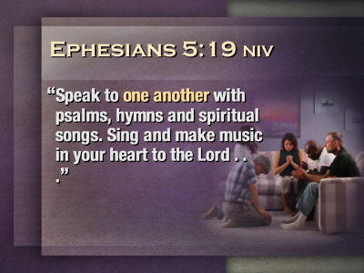60 | Ephesians 5:19 – Speak to one another with psalms, hymns and spiritual songs. Sing and make music in your heart to the Lord,
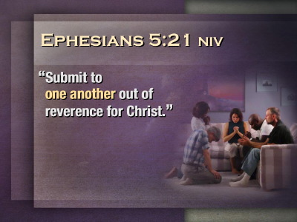61 | Ephesians 5:21 – Submit to one another out of reverence for Christ.
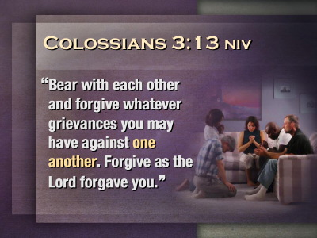62 | Colossians 3:13 – Bear with each other and forgive whatever grievances you may have against one another. Forgive as the Lord forgave you.
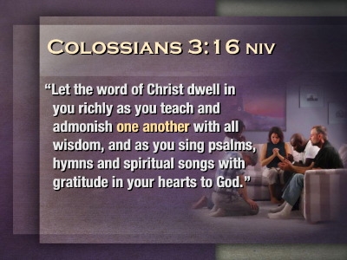63 | Colossians 3:16 – Let the word of Christ dwell in you richly as you teach and admonish one another with all wisdom, and as you sing psalms, hymns and spiritual songs with gratitude in your hearts to God.
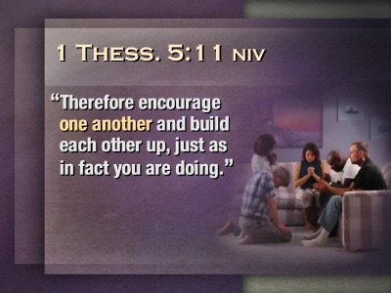64 | 1 Thessalonians 5:11– Therefore encourage one another and build each other up, just as in fact you are doing.
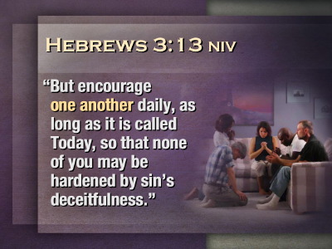65 | Hebrews 3:13 – But encourage one another daily, as long as it is called Today, so that none of you may be hardened by sin's deceitfulness.
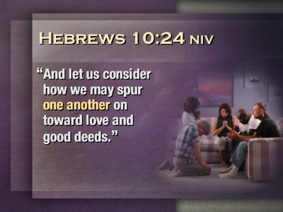66 | Hebrews 10:24 – And let us consider how we may spur one another on toward love and good deeds.
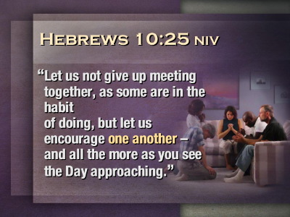67 | Hebrews 10:25 – Let us not give up meeting together, as some are in the habit of doing, but let us encourage one another-- and all the more as you see the Day approaching.
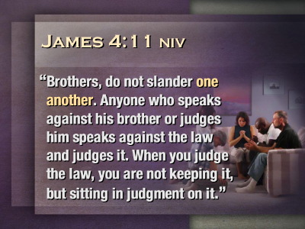68 | James 4:11 – Brothers, do not slander one another. Anyone who speaks against his brother or judges him speaks against the law and judges it. When you judge the law, you are not keeping it, but sitting in judgment on it.
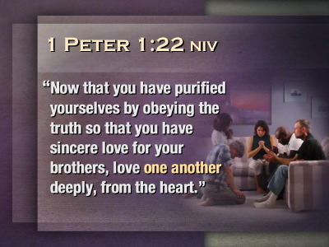69 | 1 Peter 1:22 – Now that you have purified yourselves by obeying the truth so that you have sincere love for your brothers, love one another deeply, from the hear
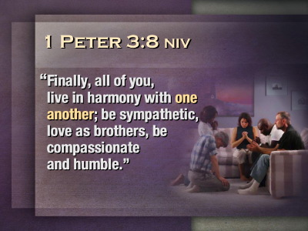70 | 1 Peter 3:8 – Finally, all of you, live in harmony with one another; be sympathetic, love as brothers, be compassionate and humble.
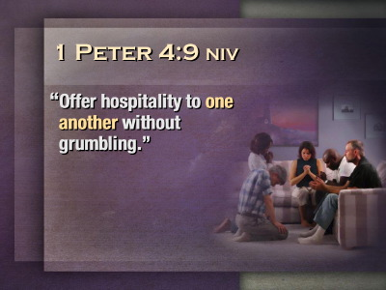71 | 1 Peter 4:9 – Offer hospitality to one another without grumbling.
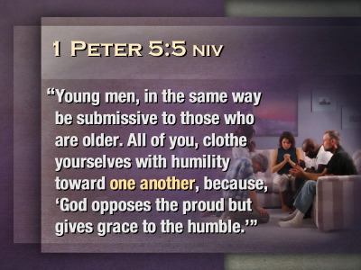72 | 1 Peter 5:5 – Young men, in the same way be submissive to those who are older. All of you, clothe yourselves with humility toward one another, because, ‘God opposes the proud but gives grace to the humble.’
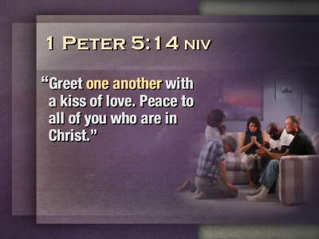73 | 1 Peter 5:14 – Greet one another with a kiss of love. Peace to all of you who are in Christ.
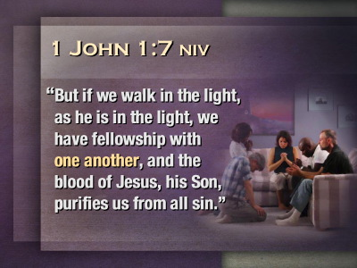74 | 1 John 1:7 – But if we walk in the light, as he is in the light, we have fellowship with one another, and the blood of Jesus, his Son, purifies us from all sin.
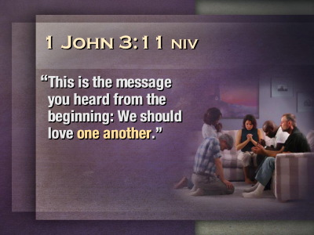75 | 1 John 3:11 – This is the message you heard from the beginning: We should love one another.
76 | Closing Slide
77 | Blank Screen (x2)
TITLE    VERSE    PARAGRAPH    ART / PHOTO | At the end of the PowerPoint presentation you will find a series of blank templates for use in your presentations according to the license agreement. For more artwork and templates, visit www.iiwdmg.com/218

